**HOTEL BOOKING DATA ANALYSIS**

**Business Problem**

*In recent years, City Hotel and Resort Hotel have seen high cancellation rates. Each hotel is not dealing with a number of issues as a result, including fewer revenues and less than ideal hotel room use. Consequently, lowering cancellation rates is both hotels’ primary goal in order to increase their efficiency in generating revenue, and for us offer thorough business advice to address this problem.*

*The analysis of hotel booking cancellation as well as other factors that have no bearing on their business and yearly revenue generation are the main topics of this report.*

**Assumptions**

1. No unusual occurrences between 2015 and 2017 will have a substantial impact on the data used.
2. The information is still current and can be used to analyse a hotel’s possible plans in an efficient manner.
3. There are no unanticipated negatives to the hotel employing any advised technique.
4. The hotels are not currently using any of the suggested solutions.
5. The biggest factor affecting the effectiveness of earning income is booking cancellations.
6. Cancellations result in vacant rooms for the booked length of time.
7. Clients make hotel reservations the same year they make cancellations.

**Research Questions**

1. What are the variables that affect hotel reservations cancellations?
2. How can we make hotel reservations cancellations better?
3. How will hotels be assisted in making pricing and promotional decisions?

**Hypothesis**

1. More cancellations occur when prices are higher.
2. The majority of clients are coming from offline travel agents to make their reservations.

**Research Findings**

1. **Cancellations**

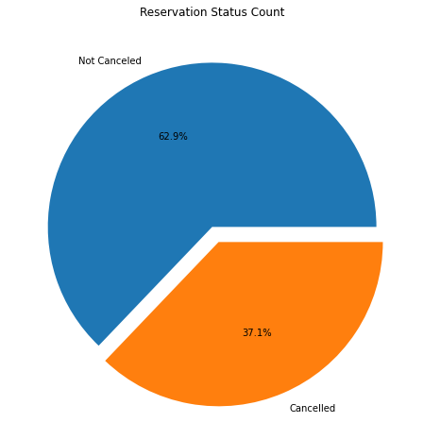

The above graph shows the percentage of reservations that are cancelled and those that are not. It is obvious that there are still a significant number of reservations that have not been cancelled. There are still 37% of clients who cancelled their reservation, which has a significant impact on the hotel's earnings.

1. **Number Of Bookings**

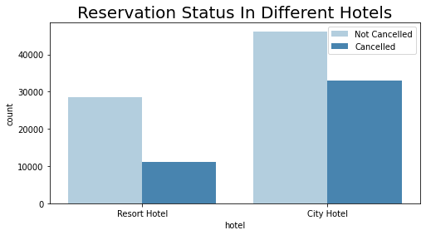

In comparison to Resort Hotels, City Hotels have more bookings. It is possible that due to its proximity to the city, City Hotels have more bookings.

1. **Correlation Between Price and Cancellation (Hypotheses #1)**

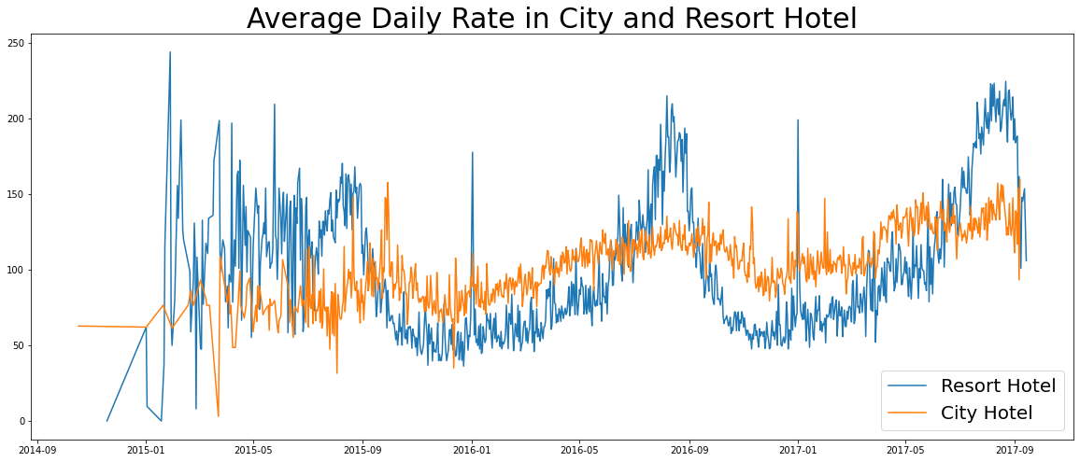

The graph proves that City Hotel has a higher average price as well as a higher cancellation rate (41.7%) compared to Resort Hotel which is cheaper, as well as has lower cancellation rates (27.9%).

But does it influence the cancellation rate? Let’s find out!

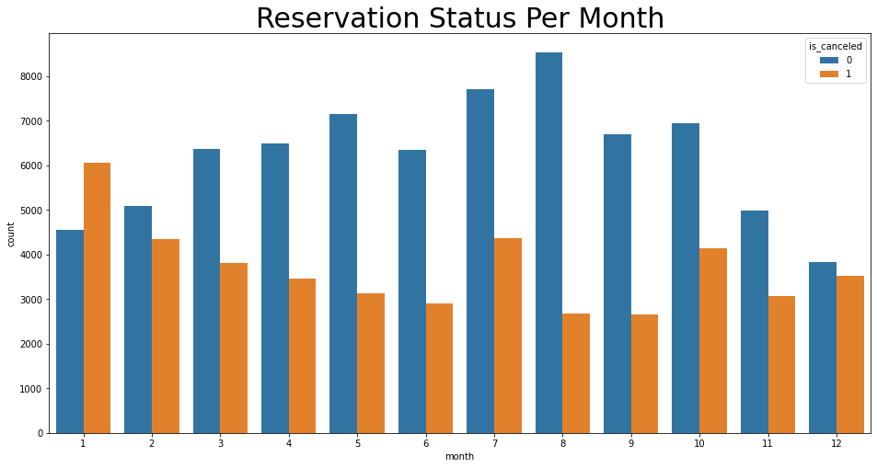

The above bar graph represents the months with the highest and lowest reservation levels according to reservation status. We can analyse, the highest number of cancelled ‘1’ is in the month of January and the highest number of reservations ‘0’ in the month of August.

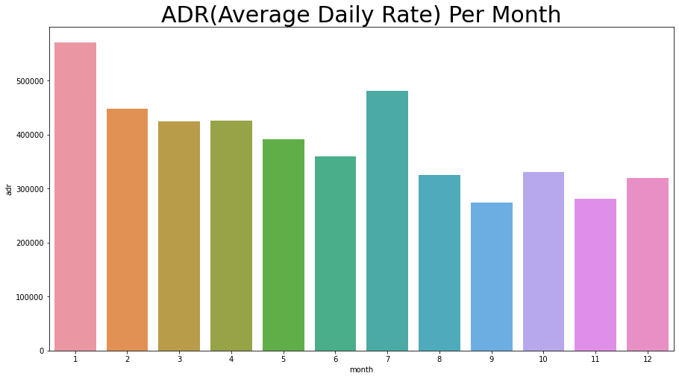

To prove that price and cancellations are directly correlated, the Average Daily Rate Per Month graph (given above) can help us demonstrate that cancellations are most common when prices are the greatest (Month of January).

1. **Top Countries with Highest Cancellations**

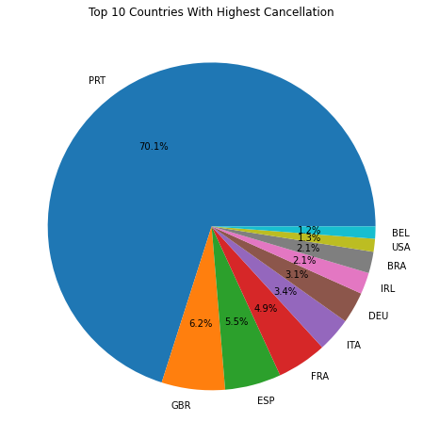

Portugal is the top country which has the highest cancellation percentage (70.1%)

1. **Majority of Clients (Hypotheses #2)**

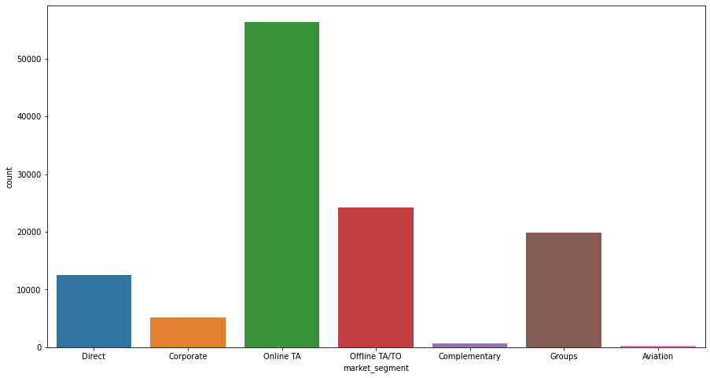

The area from where guests are making the most reservations is through the Online Travel Agent channel (represented by green bar).

**Suggestions**

1. Cancellation rates rise as the price does. In order to prevent cancellations of reservations, hotels could work on their pricing strategies and try to lower the rates for specific hotels based on locations. They can also provide some discounts to the customers.
2. In the month of January, hotels can start campaigns advertising sales and subsidised rates to increase their revenue as the cancellation is the highest in this month.
3. They can also double down in increasing the quality of their hotels and their services mainly in Portugal to reduce its high cancellation rate.

**End of report**